Our City Experiences: ParCITYpate
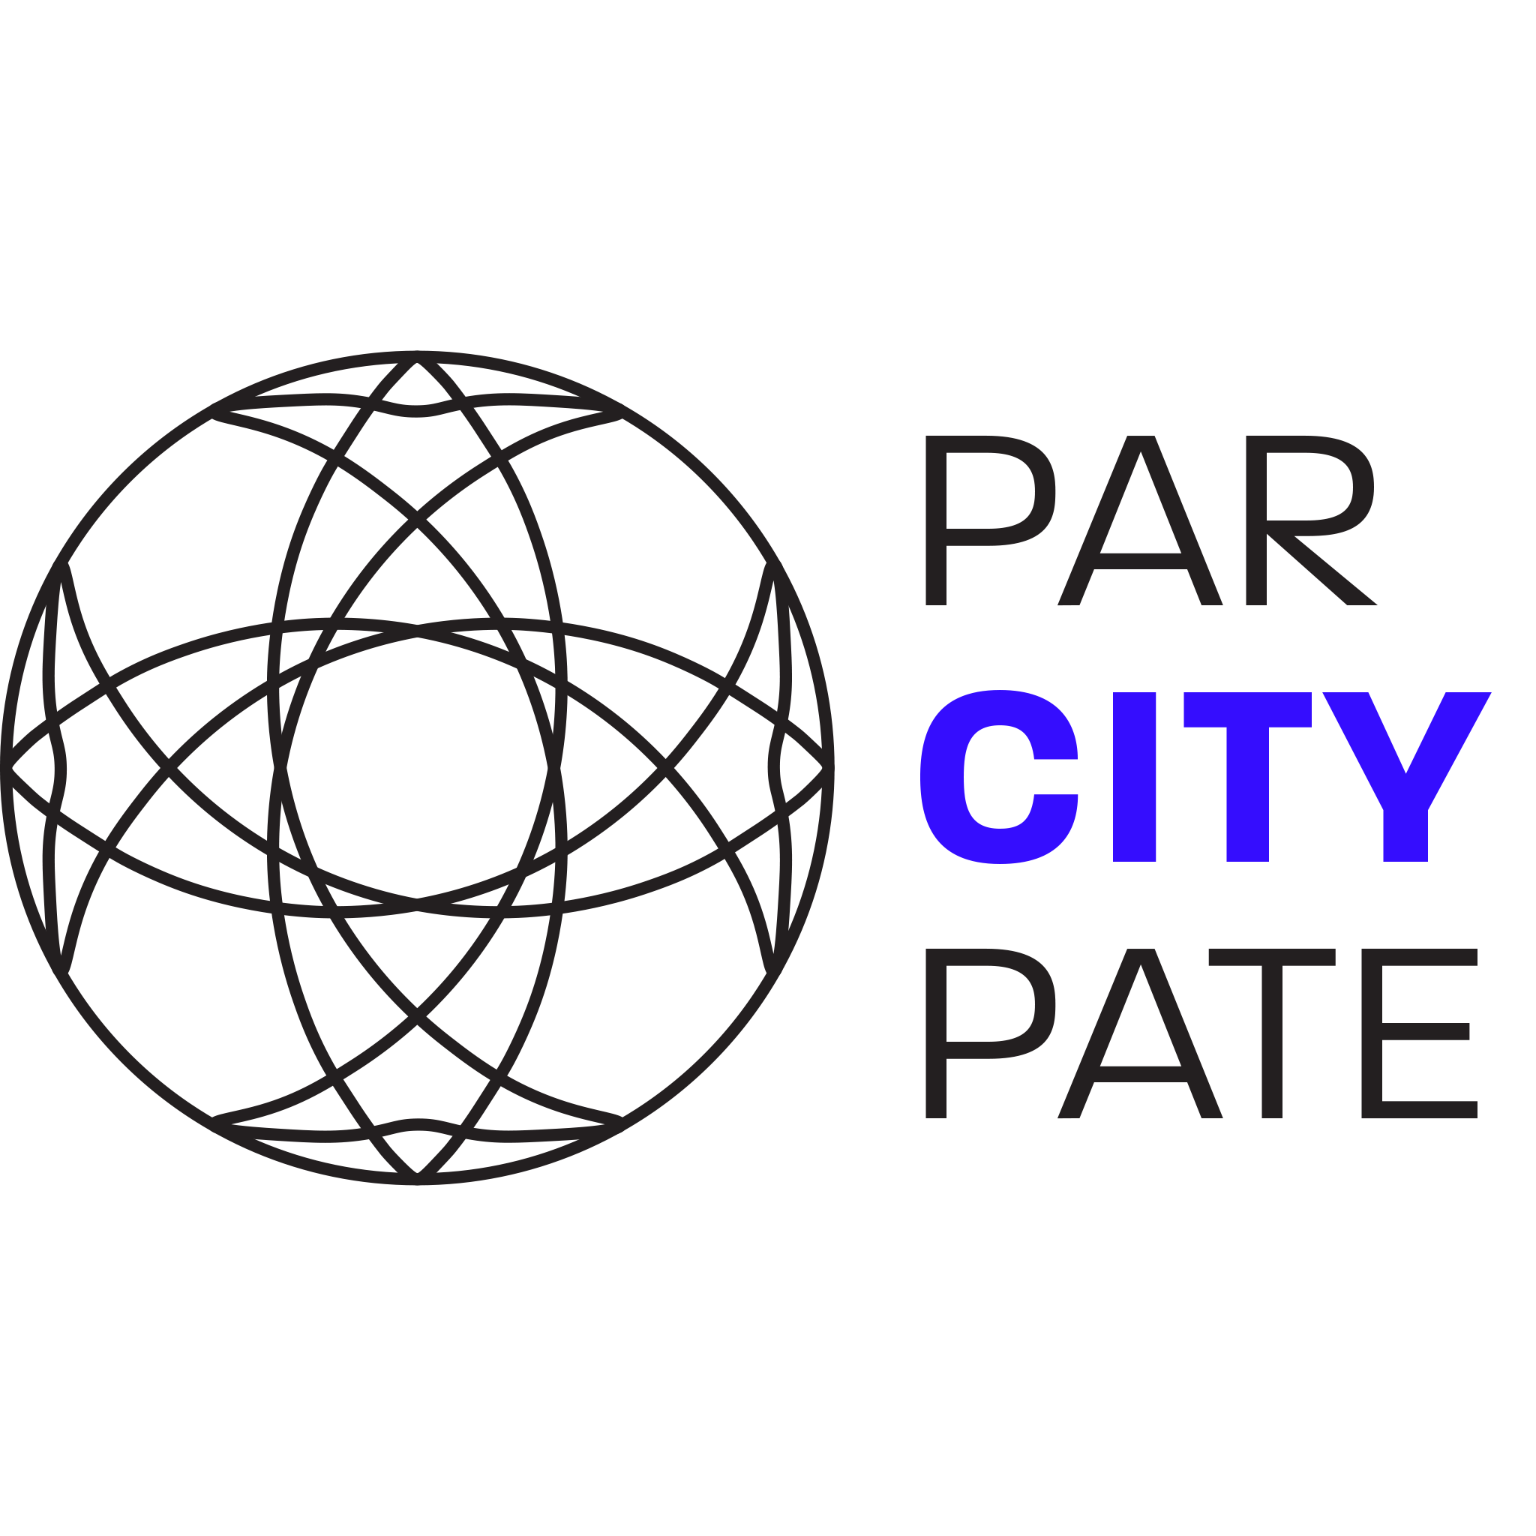

Project Summary
Involving people in urban planning offers many benefits, but current methods are failing to get a large number of citizens to participate. People have a high participation barrier when it comes to public participation in urban planning, as it requires a lot of time and initiative only a small non-diverse group of citizens take part in governmental initiatives. This fact prevents the productivity of citizen participation and can lead to dissatisfaction among the population. Even the use of modern methods in a smart city has not yet succeeded in finding a comprehensive solution. This project is intended to contribute to the solution of the aforementioned problem. A combination of a public screen with a visual experience and an active interaction through a website (on a smartphone) will make it easier for citizens to participate. A public screen is placed at the location of a future construction project and is intended to arouse the curiosity of passers-by. The screen will display 3D models of the construction project to provide visualization at the future location, in addition, the screen will display information about the project, comments, and feedback from citizens. The interaction of the population with the screen should be done via a smartphone with the help of a web application. Using a QR code, it is possible to access the website without having to make any prior arrangements (downloading an app). Several citizens can simultaneously call up further information on the construction project and record their opinion in the form of comments or likes. Active interaction with the public screen is only allowed to one person at a time. This citizen gets the possibility to project different models of the building project on the screen and to move them three-dimensionally, for this a limited time window is provided so that a long occupation by a citizen can be excluded. Experience from previous studies should be taken into account to ensure the success of the project. The overall aim of this system is to reduce the barriers to participation and to inspire citizens to engage in urban planning in a fun way.
The product should achieve the following goals:
- As many as possible citizens in a city should be reached/involved
- The flow of information should be reciprocal
- It must be easy to reach and as inexpensive as possible for the citizen (inviting and easy to use)
- The participation should be with as few restrictions as possible
- Transparency, inclusion, and fairness
- Interactivity should be possible
- Participation should be possible at the location of the project
- Anonymous participation
- Be taken seriously as a participation opportunity (not as a toy)
- Possibility of participation of several persons at the same time
The following EU directives are to be mentioned as legal requirements:
- Electromagnetic Compatibility Directive (EMCD);
- Low Voltage Directive (LVD);
- Machinery Directive (MD);
- Radio Equipment Directive (RED);
- Restriction of Hazardous Substances in Electrical and Electronic Equipment Directive (ROHS)
Social requirements include:
- As environmentally friendly as possible over the product life cycle
- The inclusion of as large a population group as possible (as far as possible)
The framework:
- Budget of 100€ for the prototype
- Use open-source software and technologies when possible
- Adoption and use of the International System of Units (The NIST International Guide for the use of the International System of Units)
Functional Requirements:
- Defying environmental influences when installed outdoors
- Easy installation and maintenance
- Residents must be made aware of the opportunity to participate
- Ease of use of the application

Participants
Institution: Instituto Superior de Engenharia do Porto
Team N.2:
Students:
- Carla Gomes Cardani
- Carmen Couzyn
- Eliott Degouilles
- Jan Michael Benner
- Julia Aleksandra Engst
Panel of Supervisors:
- Abel Duarte (ajd 'at' isep 'dot' ipp 'dot' pt)
- Jorge Justo (jfj 'at' isep 'dot' ipp 'dot' pt)
- Maria Benedita Malheiro (mbm 'at' isep 'dot' ipp 'dot' pt)
- Maria Cristina Ribeiro (mcr 'at' isep 'dot' ipp 'dot' pt)
- Manuel Silva (mss 'at' isep 'dot' ipp 'dot' pt)
- Paulo Ferreira (pdf 'at' isep 'dot' ipp 'dot' pt)
- Pedro Barbosa Guedes (pbg 'at' isep 'dot' ipp 'dot' pt)

Contents
Project Planning: Deadlines, Tasks, Gantt chart, Task allocation
Logbook: Weekly Report, Meetings, Activities
Report: Report
Deliverables: Links to all deliverables

Contacts
- Carla Gomes Cardani, carla.cardani@hotmail.com
- Carmen Couzyn, 1212286@isep.ipp.pt
- Eliott Degouilles, eliott.degouilles@gmail.com
- Jan Michael Benner, jan_michael.benner@smail.th-koeln.de
- Julia Aleksandra Engst, julia.aleksandra.engst@uni-weimar.de

Utilities
- DokuWiki Syntax
- Videos on how to use DokuWiki

Acknowledgements
- Sponsor (sponsor)
- Eng.º Vítor Costa Cerqueira, DEE, ISEP (wiki installation and management)
- Prof. João Correia Lopes, DEI, FEUP (wiki template)
— EPS@ISEP Wiki Template 2012-01-15 15:35

